<Customer Name>
Virtual machine Allocation System
Design Document
Version No. 1



 | Prepared By / Last Updated By | Reviewed by | Approved By
Name
Role |  | Technical Leader | Project Leader
Signature
Date

Table of Contents
1.0 Introduction 3
1.1 Design Goals 3
2.0 Architecture 3
2.1 Data 3
2.1.1 Introduction 3
2.1.2 Schema 3
2.1.3 File and Data Formats 3
2.2 Communication 3
2.3 Code 4
2.3.1 Introduction 4
2.3.2 Features 4
2.3.2.1 Feature A 4
2.3.2.2 Feature B 5
2.3.3 Interfaces 5
3.0 Miscellanea / Appendices 5
3.1 Conformance with standards 5
3.2 Interoperability with other systems 5
3.3 Expandability 5
3.4 Glossary 5
4.0 Change Log 6

Introduction

Design Goals
The aim of this project is to design the system which allocates virtual machines to users with the proper authentication system. The user can demand virtual machines based on their need. To get virtual machine user is supposed to enter all credentials such as associate id, project name, duration of vm and software requirements. Which will be authenticated by admin. And user will demand time extension which admin will authenticate with a new password.

Architecture

Data

Introduction
There will be one SQL database which will store data related to VM subscription and user detail. The database store date in the row’s and columns. There will be another databae which will store data in the semistructured format such as JSON files. This will store software to be installed on VM.

Schema
The table will consist of 5 columns which are VM id, Associate ID, Project , VM Start time ,VM End time,and software to be installed. Here VM id will be primary key.

File and Data Formats
All the data will be stored in two ways the first will be sql database and second will be semistructure database such as mongoDB.

Communication
Whenever modules communicate, be it using TCP/IP or some other protocol, this section should indicate the following:
- Which modules do so, at what instances and for what purpose?
- Who listens and who connects.
- Which protocol is used for communication? If relevant, give a detailed description of both the protocol and the format of the exchanged data. Furthermore, explain how the protocol may accommodate future changes.

Code

Introduction
Should mention any special considerations that led to this specific design, or that should be kept in mind while implementing it. It has to include general comments about the code in addition to notes that do not fit in any specific sub-section.

Features

Feature A (VM FORM)
This will be a normal html form with some CSS design in it. It will take input directly from the user. The will take input such as associate id, project name, Vm duration and options for software to be installed on vm. After that user can click submit button. The detail will be saved in the database and a mail will be triggered to admin for permission for VM allocation. Id admin accepts the request then a random password will be generated which can be used for login purpose then the password will be sent to user for acceppentance apporoval.

2.3.2.1.1 Internal Functions ( new VM request )
- This function will save data entered by user to the database and the data for software required will be save in Jason file and location for the same will be saved in software to be installed column. And also it will call another function to save data
- The name of the function is NewVmRequest .
- This function will check wheather all details such as assocate Id is available in the database or not if not trigger error.
- It will return true when all data will be saved successfully to the database.
- This function will use inbuild function to connect with the database and to insert value to the database.
- If value updated successfully then it will trigger MailtoAdmin() Function which will send mail to admin for vm appoval.

Internal Functions (MailtoAdmin)
- Here the function name is mail to admin which will take request from user function NewVmRequest.
- This will trigger smtp server in which all messages will be added such as VM details.
- Then this will be send to Admin with a link for approval.

Feature B (ADMIN Dashbord)

2.3.2.2.1 Internal Functions (home page)
- This will display three buttons were user which are show all vm’s, show vm by date, and vm request.
- When user clicks on show all VM the user will be redirected to a new webpage which will show details of every running vm.
- This will call to Swow request function internally.
- If Admin clicks on third button which is show request then user will be redirected to a new page where he can see all request raised by employees.
- Whre admin can select options for approve and reject vm.

2.3.2.2.2 Internal function (Approve VM)
- When Admin will click approve the VM then php will call ApproveVm() function.
- This function will generate random password using inbuild functions such as random.
- Then the function will trigger mail to user which will send confirmation mail to the user with password detail.
- Then this password will be encrypted to hash with some extra random value added to it.
- Then this password will be updated to database.

2.3.2.2.3 Internal function (Show Request)
- This function will accept VM which are not assigned.
- Then this function will call approve VM function.

2.3.2.2.4 Internal function (Extend Time)
- This function will be called when user demand for time extension.
- This function will take value from admin console which generate password using some inbuild function of php.
- Then this password will be mailed to the user with request approval mail.
- Then it update new date and password in the database.

2.3.2.2.5 Internal function (Show All VM)
- This function will be called when Admin want to see all VM status.
- This function will fetch all details from Database such as vm id, os used, start date,end date and so on.
- It will use some inbuid functions such as connect which can used to connect to the database.
- By using the reference of connect function, the function will pass query for fetching data from database.
- The same can be displayed in tables on web page.

Feature C (VM FORM)

Interfaces
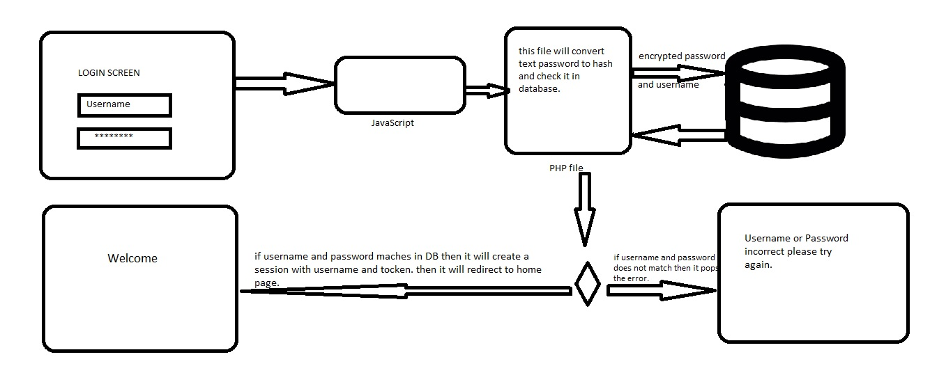
- User will enter username and password the click on submit button.
- The a java-Script program will run in background which will call a php program.
- The php program will interact with the database and give result if data is found .
- If positive result will be obtained then php will redirect to Home page else it will be on login screen with popup saying “Wrong Username or Password please try again”.

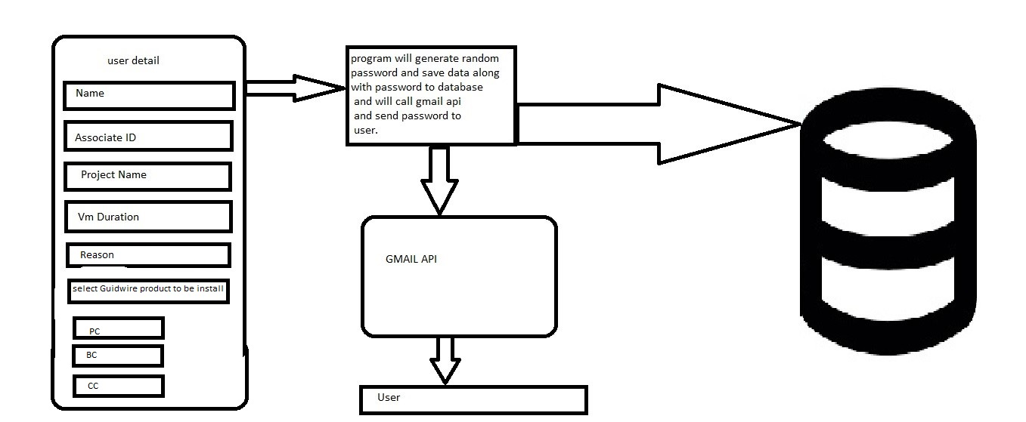
- First user will be asked to enter detail such as Name ,Associate Id ,project Name, VM duration and software which user want to pre-installed on VM.
- After clicking on Submit Button a php program will run in background which will generate a random password and send this password to User using A gmail API.
- The it will encrypt the password and save all other data along with password to the database.

VM Dashboard :-

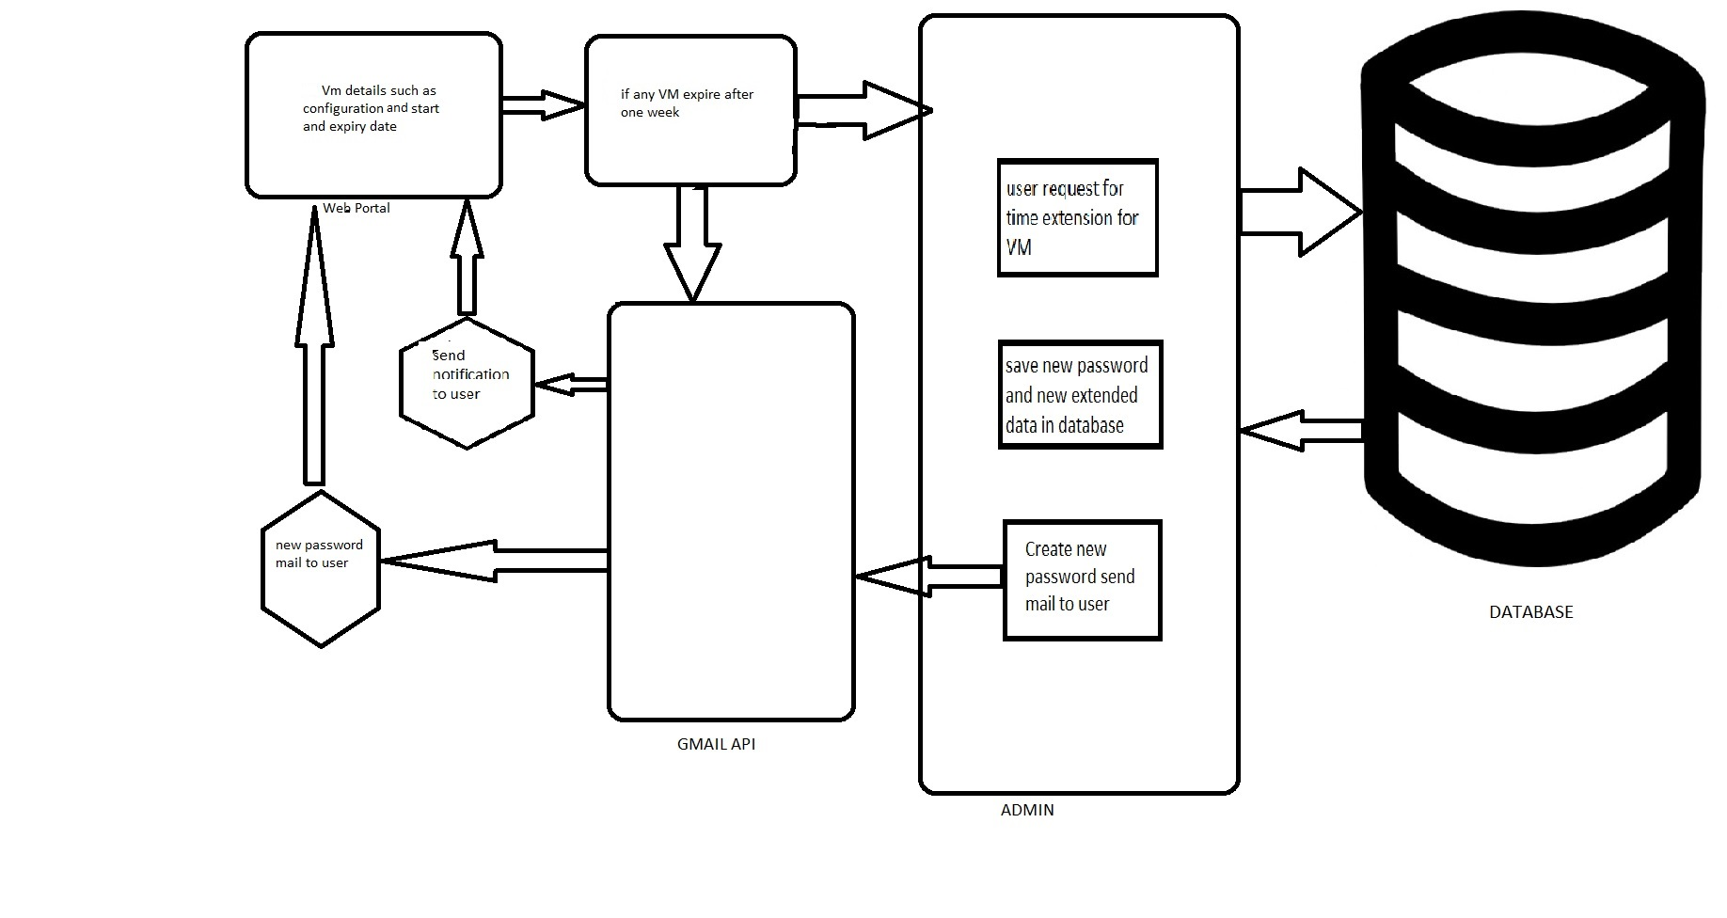

- If VM left duration is only one week then it will call a gmail API and send mail to user stating the notification for VM expiry.
- User can request Admin for Date Extension.
- If User request Admin for Date Extension then Admin Will generate new random password which and send this password to the User using Gmail API.
- Then it will encrypt the new password and replace the previous password with new one and also update new date into the database.

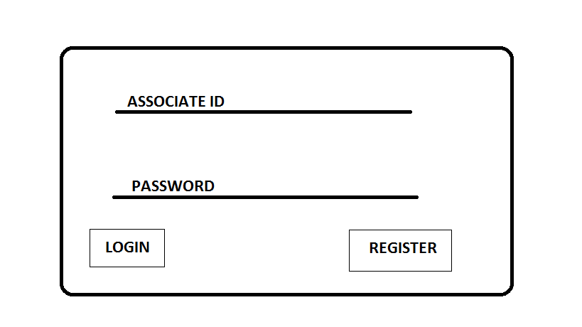
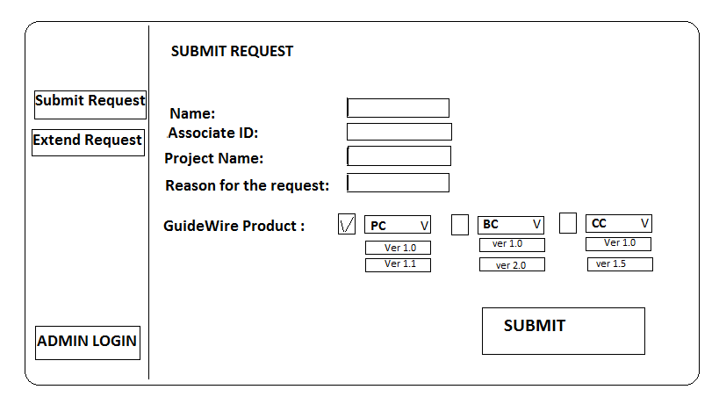
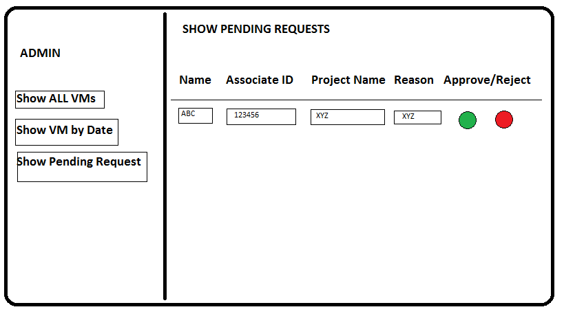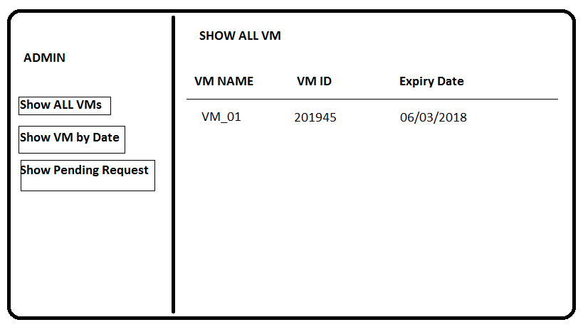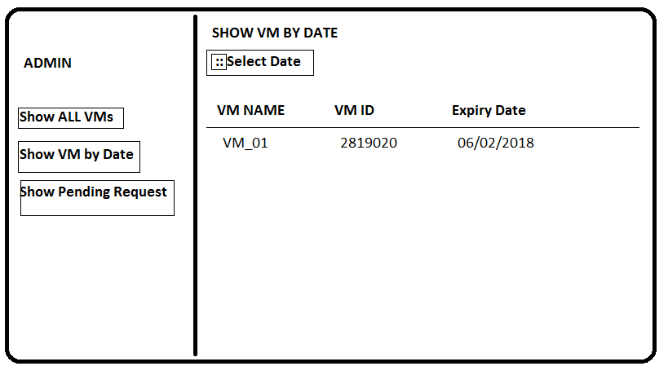

Assocaite will Login into the portal, in the portal there will be components that will show the active VM assigned to the Associate. The running/ assigned VM will have some dead date. Associate can request admin to extend the date of the VM based on the project requirement.
If there are no VM assigned to the associate then associate can raise a request by filing the form with the Associate ID, Name, Project Name, VM Type (Configurations), Date till the VM is needed. The request will trigger automatic email which will be sent to all the admins and user itself saying that the user has initiated a new request.
If the logged in associate is an admin then he/she can directly click on the admin loggin and will be automatically redirected to the admin page if he/she is an admin (which will check from the admin database), there admin can see all the VMs, admin can sort VM by date of expiry, and admin can view pending requests.
In the request tab, admin can see the associate ID, the name of the project, VM type requested and the length of duration for which the VM is needed. Based on admin’s dicision, they can approve or reject the request.
If accept then automatic Email will be triggered and every admin and user will be notified about the VM assignment.

Miscellanea / Appendices

Conformance with standards
- The system is compliant with W3C standards. It is also compatible for usage in different platforms. It is also developed to support mobile users.
- The system is also compliant with the Data security standards.
- It also ensures the privacy of the employees who use the portal.
- It is also compliant with all the standards that the organization follows.

Interoperability with other systems
The list of external systems that our application is to interact with is explained below along with the reason for the interaction:
- The system uses a high end server as the functionality of the system is to import Virtual Machines. This is because the system demands a high processing power along with the robustness and reliability the server offers.
- The system uses a high end database, which is primarily used to store, retrieve and maintain user data. The database also offers security along with consistency when being handled by multiple users concurrently. The database also offers flexible accessibility of data.
- The system also uses a high end semi structured data that contains the software that are needed for compatible usage.

Expandability
The system is built on a smaller scale with further updates needed that increases the scalability of the system.
- The system also could be upgraded with a plugin which allows user to customize their portal’s interface.
- The system is primarily focused on Virtual Machine Allocation, while the further updates on the system could facilitate the access of other virtual resources as well.
- It contains a table with a list of plug-ins that are needed to view the information in various file formats.

Glossary

The aim of this project is to design the system which allocates virtual machines to users with the proper authentication system. The user can demand virtual machines based on their need. To get virtual machine user is supposed to enter all credentials such as associate id, project name, duration of vm and software requirements. Which will be authenticated by admin. And user will demand time extension which admin will authenticate with a new password..

Change Log
Please note that this table needs to be maintained even if a Configuration Management tool is used.
Version Number | Changes made
V1.0 | <First version>
V1.1 | <If the change details are not explicitly documented in the table below, reference should be provided here>
V1.1 | Page no | Changed by | Effective date | Changes effected
V1.2 | <If the change details are not explicitly documented in the table below, reference should be provided here>
V1.2 | Page no | Changed by | Effective date | Changes effected

